|  |  |
| --- | --- |
| **Ayush Khaneja** | **Fall 2023** |
| **Paper Proposal 1** | |

**The Saudi Pro League: The Next Big Fan-Favorite?**

**The Rise of the Popularity of the Saudi Pro Football League and the Role of Cristiano Ronaldo in Bringing About this Change**

**(449 Words)**

**Research Questions:**

* There is a large shift in the transfer destinations for pro football players at the top of their game. Europe is no longer the only option to play in, and players are flocking to the Saudi Pro League, especially this season. With the quality of football not being the same level as Europe, how do the fans feel about this changing trend? Are they showing their support to the Saudi League?[1], [2]
* Cristiano Ronaldo seems to be a major reason for the growing popularity of the Saudi League. How important is his role in popularizing the league globally?[2], [3]

**Background:**

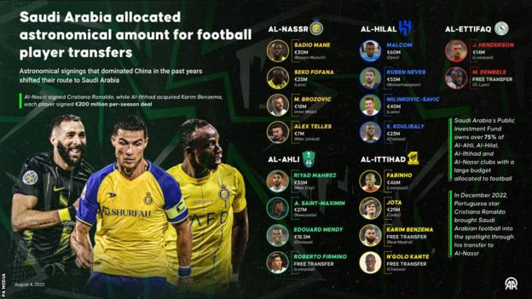

<https://www.bbc.com/sport/football/66448739>

The Saudi Pro League has been competing with the top European leagues this season in terms of transfer budgets and big names transferred. It has been the destination of choice for some of the top footballing talents of the current generation. But not everyone is happy with this change.[4] Some football fans are of the opinion that this trend is ruining football. Players are headed to the Saudi League only to make money, and are not passionate enough about playing football. Others think that the money allocated for football could have been allocated elsewhere. The research aims to find out what fans are saying about the league and how positive their sentiment is towards it. Another factor being analyzed is the presence of Cristiano Ronaldo. Before his transfer, the Saudi League wasn’t talked about as much, and there was not as much mention of it in mainstream football. The research also focuses on seeing how much impact, if any, has Ronaldo had in changing the face of the Saudi League.

**Data:**

Data will be collected by analyzing the posts and comments that mention the Saudi Pro League on r/football, r/soccer and other sports-related communities on Reddit. This data will be collected manually. The time period will be the last 5 years. Instagram pages like brfootball etc. will also be used to see the frequency of the number of posts about the Saudi League in recent times (especially after the Ronaldo Transfer) vs. a while ago, and how many of these posts mention Ronaldo.

**Method:**

The post and comment data from Reddit will be custom-coded to se the type of response (positive, neutral, negative) about the Saudi League, and the frequency of posts will show the change in popularity. Another custom-coded dataset will be built to track the type of posts and comments about the league (Player/team-related, Critical About the League, In support of the league etc.). Posts and comments mentioning Cristiano Ronaldo as well will also be tracked separately to quantify his influence. The fan sentiments and Ronaldo’s influence will be analyzed both statistically and visually.

**References:**

[1] Binjwaied, M., Richards, I., & O'Keeffe, L. A. (2015). The factors influencing fans’ attendance at football matches in the Kingdom of Saudi Arabia. Athens Journal of Sports, 2(2), 111-122.

[2] Ghosh, Arpan (February 10, 2023). Saudi Arabian league’s viewership increases 7 times after Cristiano Ronaldo’s move to Al Nassr: Reports. <https://firstsportz.com/saudi-arabian-leagues-viewership-increases-7-times-after-cristiano-ronaldos-move-to-al-nassr-reports/>

[3] Schreyer, D., & Singleton, C. (2023). Cristiano of Arabia: Did Ronaldo increase Saudi Pro League attendances?. Available at SSRN 4552736.

[4] Syed, Armani (August 11, 2023). Saudi Pro League Spent Big Money on Big Stars. But the Fans Aren't a Sure Bet. <https://time.com/6304203/strongsaudi-arabia-soccer-pro-league/>